Mandate Products Tags
M2LastProfileUpdateDate
[m2LastProfileUpdateDate]
M2MandateProducts
[m2MandateProducts]

Portfolio Tags
M2PortfolioTable
[m2PortfolioTable]

Profile Category Tags
M2ProfileTable
[m2ProfileTable<PersonalDetails>]
M2ProfileTable Optional
[m2ProfileTable<PersonalDetails>Optional]

Example Results:

Mandate Products Tags
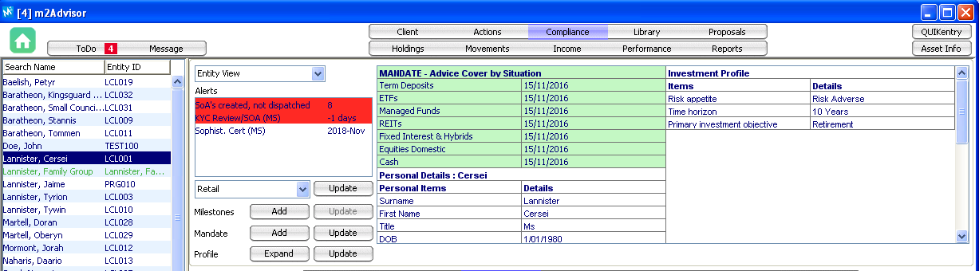
M2LastProfileUpdateDate
19/10/2016
M2MandateProducts
Products Covered in this Statement of Advice
Cash
Equities Domestic
Fixed Interest and Hybrids
Real Estate Investment Trusts
Managed Funds
Exchange Traded Funds
Term Deposits

Portfolio Tags
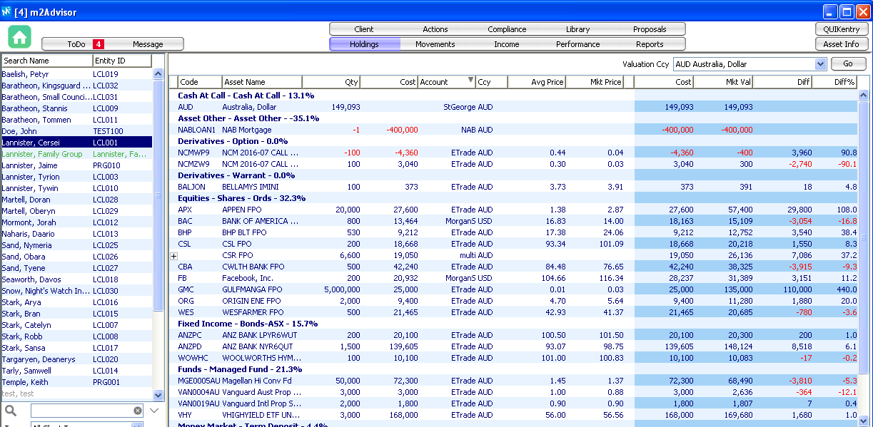
M2PortfolioTable
Asset Name | Quantity | Market Value
Australia, Dollar | 149,093 | 149,093.00
25 Red Bluff Road | 1 | 550,000.00
ANZ BANK LPYR6WUT | 200 | 20,299.80
ANZ BANK NYR6QUT | 1,500 | 148,123.50
APPEN FPO | 20,000 | 57,400.00
BANK OF AMERICA CORP | 800 | 15,108.80
BELLAMYS IMINI | 100 | 391.00
BHP BLT FPO | 530 | 12,751.80
CBA TermDep 60 Days 2.15% | 50,000 | 50,000.00
CSL FPO | 200 | 20,218.00
CSR FPO | 6,600 | 26,136.00
CWLTH BANK FPO | 500 | 38,325.00
Facebook, Inc. | 200 | 31,388.53
GULFMANGA FPO | 5,000,000 | 135,000.00
Magellan Hi Conv Fd | 50,000 | 68,490.00
NAB Mortgage | -1 | -400,000.00
NCM 2016-07 CALL $24.50 | -100 | -400.00
NCM 2016-07 CALL $25.50 | 100 | 300.00
ORIGIN ENE FPO | 2,000 | 11,280.00
Vanguard Aust Prop Secs | 3,000 | 2,636.40
Vanguard Intl Prop Secs | 2,000 | 1,806.60
VHIGHYIELD ETF UNITS | 3,000 | 169,680.00
WESFARMER FPO | 500 | 20,685.00
WOOLWORTHS HYM3QUT | 100 | 10,083.00
Estimated Total Portfolio Value AUD |  | 1,138,796.43

Profile Category Tags
M2ProfileTable
Cersei
Personal Items | Details
Surname | Lannister
First Name | Cersei
Title | Ms
DOB | 1/01/1980
Country of Citizenship | Australia
Tax Resident of Australia | Yes
Marital Status | Widow

M2ProfileTable Optional
Cersei
Personal Items | Details
Surname | Lannister
First Name | Cersei
Title | Ms
DOB | 1/01/1980
Country of Citizenship | Australia
Tax Resident of Australia | Yes
Marital Status | Widow

