Record of Advice Tags
M2AdviceDate
[m2AdviceDate]
M2AdviceDeclarations
[m2AdviceDeclarations]
M2AdviceGiver
[m2AdviceGiver]
M2AdviceModeDesc
[m2AdviceModeDesc]
M2AdviceRecipient
[m2AdviceRecipient]
M2AdviceTable
[m2AdviceTable]
M2AdviceTableExtend
[m2AdviceTableExtend]
M2AdviceTime
[m2AdviceTime]

Example Results:
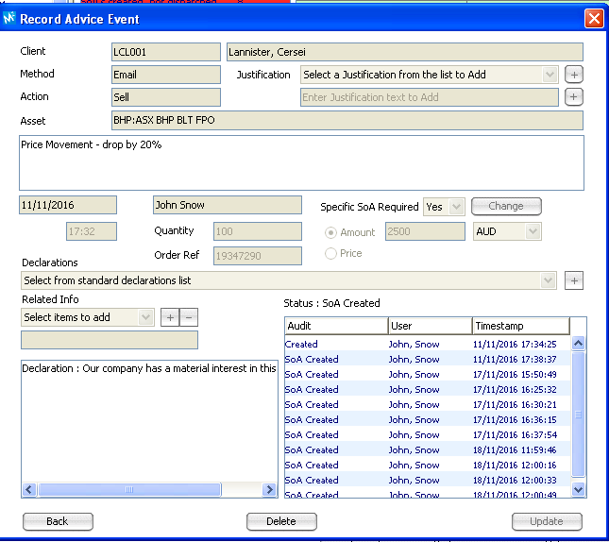

M2AdviceDate
11/11/2016
M2AdviceDeclarations
Our company has a material interest in this commpany.
M2AdviceGiver
John Snow
M2AdviceModeDesc
Phone
M2AdviceRecipient
Mrs Cersei Lannister
M2AdviceTable
Date | Product | Advice | Advice Reason
11/11/2016 | BHP BLT FPO | Sell | Price Movement - drop by 20%

M2AdviceTableExtend
Date | Product | Advice | Qty | Cost | Advice Reason
11/11/2016 | BHP BLT FPO | Sell | 100 | 2,500 | Price Movement - drop by 20%

M2AdviceTime
17:32

