Dates Tags
M2TodayDate
[m2TodayDate]
M2SelectSoaDispatchDate
[m2SelectSoaDispatchDate]
M2SelectSoaEffectiveDate
[m2SelectSoaEffectiveDate]

Dynamic Options Tags
M2Insert
[m2Insert<Inserting Free Text: {Please enter your text here}>]
M2OptionalSectionStart & M2OptionalSectionEnd
[m2OptionalSectionStart<what is here?>]
This is an “Optional Section” for m2OptionalSectionStart & End.
[m2OptionalSectionEnd]
M2SelectOne
[m2SelectOne<Selecting One Option{
Option A
Option B
Option C
Option D
Option E
}>BulletList]

M2SelectMultiple
[m2SelectMultiple<Selecting Multiple Option List{
Option 1
Option 2
Option 3
Option 4
Option 5
}>BulletList]

Example Results:
Dates Tags
M2TodayDate
18/11/2016
M2SelectSoaDispatchDate
18/10/2016
M2SelectSoaEffectiveDate
18/10/2016

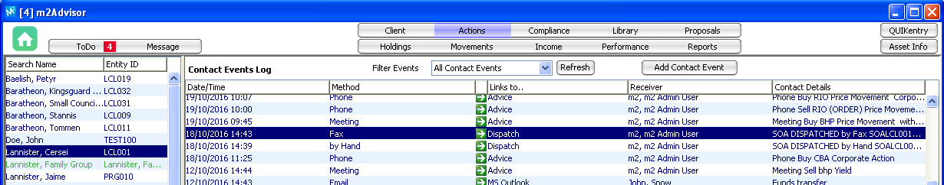
Dynamic Options Tags
M2Insert
Please enter your text heretest
M2OptionalSectionStart & M2OptionalSectionEnd

This is an “Optional Section” for m2OptionalSectionStart & End.

M2SelectOne
- Option B

M2SelectMultiple

- Option 1
- Option 2
- Option 3
- Option 4
- Option 5

