Client Information Tags
M2ClientAccountName
[m2ClientAccountName]
M2ClientAddress
[m2ClientAddress]
M2ClientAddressFull
[m2ClientAddressFull]
M2ClientFirstName
[m2ClientFirstName]
M2ClientFullName
[m2ClientFullName]
M2ClientID
[m2ClientID]
M2ClientName
[m2ClientName]
M2ClientNameConditional1
[m2ClientNameConditional1]
M2ClientNameConditional2
[m2ClientNameConditional2]
M2ClientText
[m2ClientText<DocVariable1>]
M2ClientTitleSurname
[m2ClientTitleSurname]

Advisor Information Tags
M2ExecEmail
[m2ExecEmail]
M2ExecName
[m2ExecName]

Example Results:

Client Information Tags
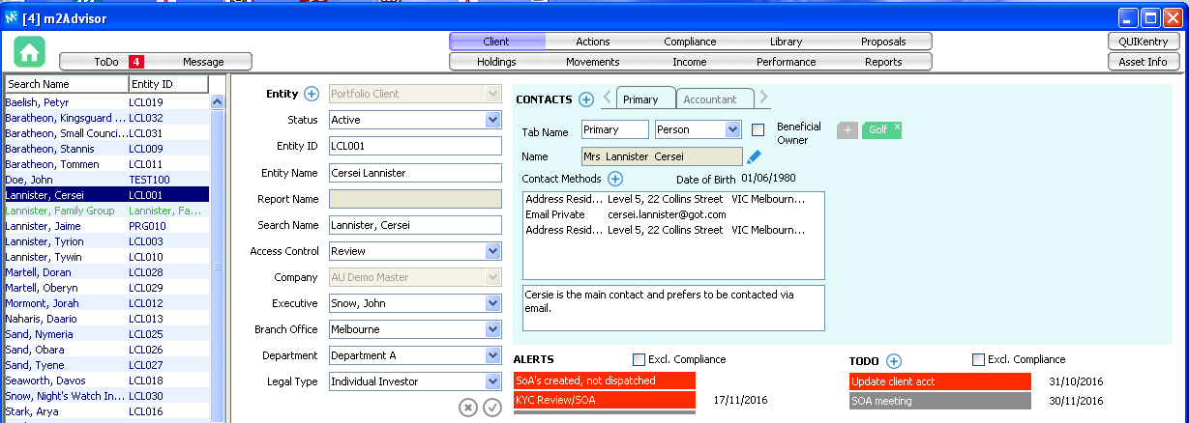
M2ClientAccountName
Cersei Lannister
M2ClientAddress
Level 5, 22 Collins Street
Melbourne
VIC 3000
M2ClientAddressFull
Level 5, 22 Collins Street
Melbourne
VIC 3000
Australia
M2ClientFirstName
Cersei
M2ClientFullName
Mrs Cersei Lannister
M2ClientID
LCL001
M2ClientName
Cersei Lannister
M2ClientNameConditional1
Mrs Cersei Lannister
M2ClientNameConditional2
Mrs Cersei Lannister
M2ClientText
What is this?
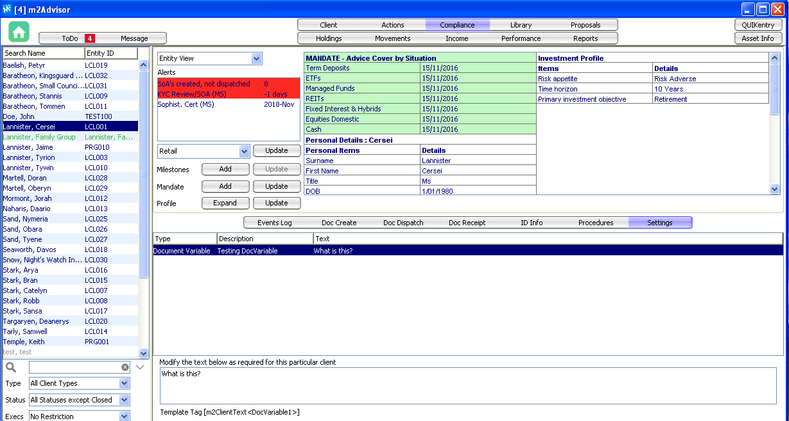
M2ClientTitleSurname
Mrs Lannister

Advisor Information Tags
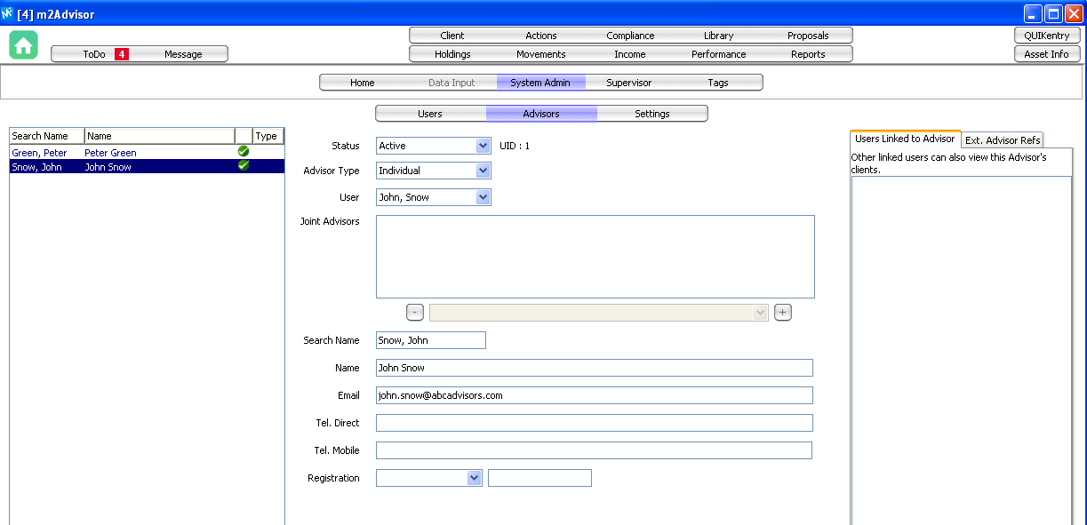
M2ExecEmail
john.snow@abcadvisors.com
M2ExecName
John Snow

